Practice 4

Determine the validity of the following three statements. Circle either True or False.

1. Group functions work across many rows to produce one result per group. True/False
2. Group functions include nulls in calculations. True/False
3. The WHERE clause restricts rows before inclusion in a group calculation. True/False

The HR department needs the following reports:

1. Find the highest, lowest, sum, and average salary of all employees. Label the columns Maximum, Minimum, Sum, and Average, respectively. Round your results to the nearest whole number. Place your SQL statement in a text file named lab_04_04.sql.



1. Modify the query in lab_04_04.sql to display the minimum, maximum, sum, and average salary for each job type. Resave lab_04_04.sql as lab_04_05.sql. Run the statement in lab_04_05.sql.

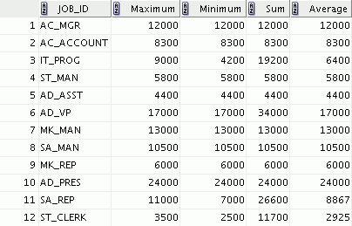

1. Write a query to display the number of people with the same job.

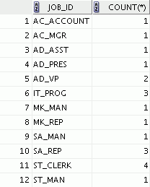

Generalize the query so that the user in the HR department is prompted for a job title. Save the script to a file named lab_04_06.sql.

1. Determine the number of managers without listing them. Label the column Number of Managers. *Hint: Use the MANAGER_ID column to determine the number of managers.*



1. Find the difference between the highest and the lowest salaries. Label the column

DIFFERENCE.



If you have time, complete the following exercises:

1. Create a report to display the manager number and the salary of the lowest-paid employee for that manager. Exclude anyone whose manager is not known. Exclude any groups where the minimum salary is $6,000 or less. Sort the output in descending order of salary.

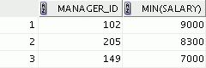

If you want an extra challenge, complete the following exercises:

1. Create a query to display the total number of employees and, of that total, the number of employees hired in 1995, 1996, 1997, and 1998. Create appropriate column headings.



1. Create a matrix query to display the job, the salary for that job based on the department number, and the total salary for that job, for departments 20, 50, 80, and 90, giving each column an appropriate heading.

